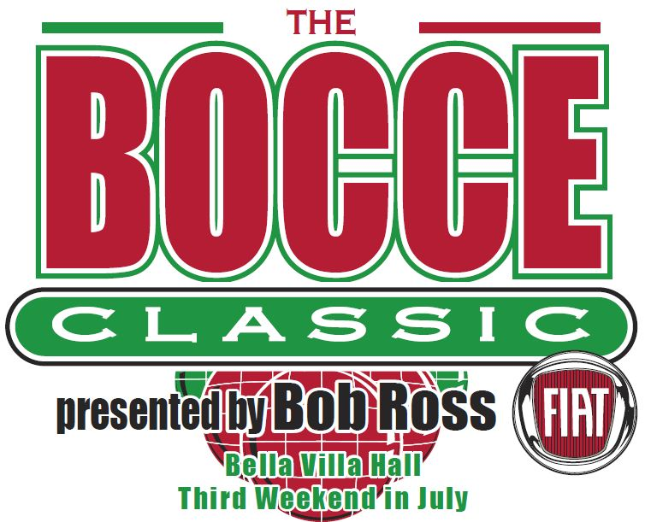
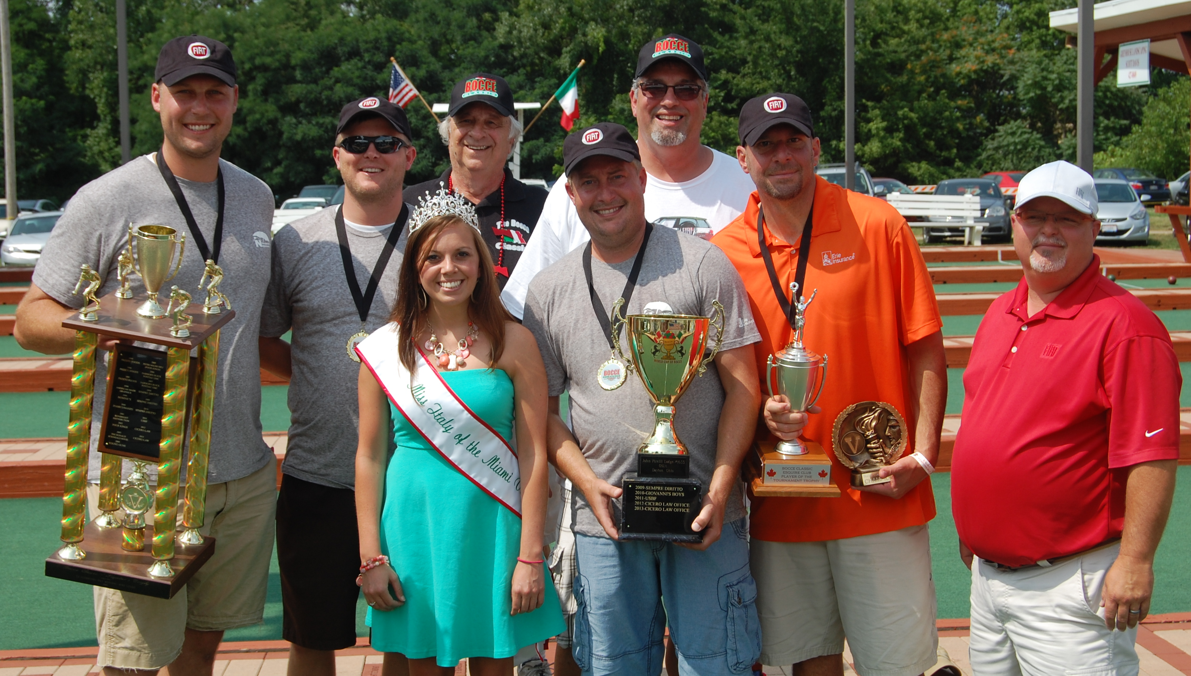
BOCCE CLASSIC XXI

REGISTRATION FORM

JULY 18-19, 2015

MINIMUM OF FOUR (4) PERSON TEAM

ENTRY FEE - $250 per team
2014 BC XX Holobaugh Insurance

TEAM NAME: _________________________________________________________________

CAPTAIN’S NAME:_________________________________________________________________________________________

ADDRESS:_________________________________________________________________________________________________

CITY,______________________________________________________STATE, _____________ZIP_____________________

TELEPHONE# ___________________________________(Email)____________________________________________________

PLAYER’S NAMES: | SATURDAY  OUTBACK  DINNER  Included for 4 players | MEATBALL SAUSAGE SANDWICH $4 | PIZZA  $8 | FIAT 500  Make checks payable to Ohio Grand Lodge Foundation
 | included |  |  | Each Raffle
 | included |  |  | Ticket $10
 | included |  |  | Please Submit
 | included |  |  | Separate
 | $12 |  |  | Payment
 | $12
NON-PLAYER DINNER TICKETS | ___x $12
PRE SALE COLUMN TOTAL $
No Outside Food or Drink Entry Fee: $ 250
Make Entry Fee Check Payable to The Bocce Classic Pre Sale Tickets $_____________
First $2500 Second $1500 Third $1000 guaranteed Total Submitted: $_____________
In US Dollars
Please note that any outside food or beverage not approved by the director and/or tournament staff will result in automatic forfeiture of any/all entry money, prize money and disqualification from the tournament. I want your team can have an enjoyable and fun tournament; however the liability and tax issues have to be observed.

Team Captains Signature ____________________________ Date _________________

Bocce Classic Chairman Kevin Sorice 937-475-0357
All entry forms and registration fees must be received by July 11, 2015.
Checks payable to: The Bocce Classic
Registration forms and entry fees should be mailed to: The Bocce Classic PO Box 292123, Kettering, OH. 45429-2123.
For more information, please contact: http://www.bocceclassic.com or email bocceclassic@yahoo.com
Proceeds benefit The Bocce Classic Scholarship, the Kettering Relay for Life Cancer fund, Oak Tree Corner, The OSIA Grand Lodge Foundation, Cultural and Heritage Commission, and Societa Di Mutuo Soccorso Italiana, Dayton, Ohio

